Oceans Will Part/무너진 내 맘에

Key: B (Use capo 2)
Intro: F#m7 – C#m7 - | D | F#m7 – C#m7 - | D |

A Asus4 A Asus4
If my heart has grown cold, there Your love will unfold;
F#m7 C#m7 D E
As You open my eyes to the work of Your hand.
A Asus4 A Asus4
When I’m blind to my way, there Your Spirit will pray;
F#m7 C#m7 D E
As You open my eyes to the work of Your hand,
F#m7 C#m7 D E
As You open my eyes to the work of Your hand.

A Esus
Oceans will part; nations come
D Esus A Esus
At the whisper of Your call.
A Esus
Hope will rise; glory shown.
D Esus A (E)
In my life, Your will be done.

A Asus4 A Asus4
Present suffering may pass; Lord, Your mercy will last;
F#m7 C#m7 D E
As You open my eyes to the work of Your hand.
A Asus4 A Asus4
And my heart will find praise, I’ll delight in Your way,
F#m7 C#m7 D E
As You open my eyes to the work of Your hand,
F#m7 C#m7 D E
As You open my eyes to the work of Your hand.
Used by Permission. CCLI #11103902

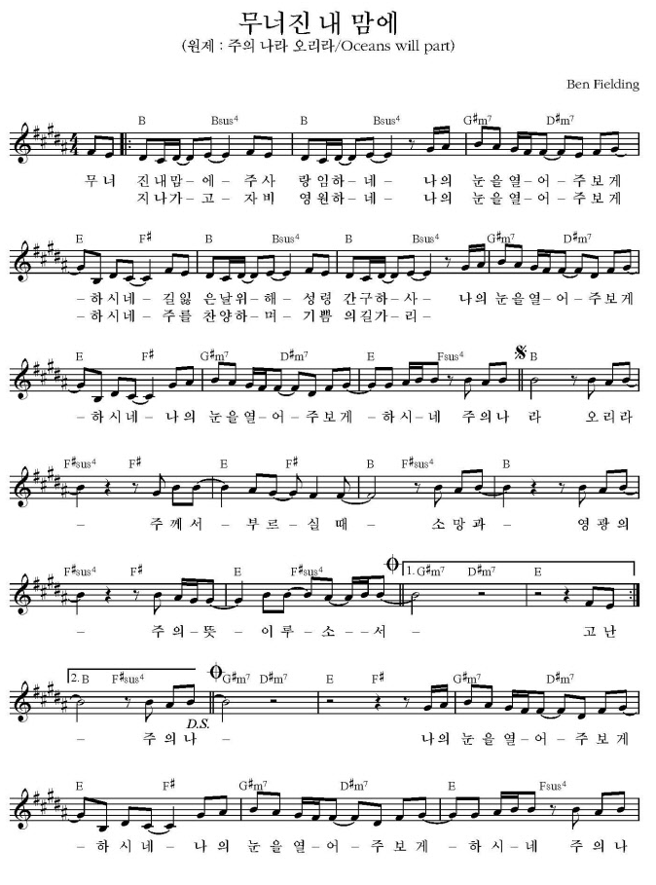
Used by Permission. CCLI #11103902

